WormLocoSimulator
Last update on 10/18/2013
User Manual

I. Copyright & Disclaimer
The WormLocoSimulator software is freeware. Anyone can install the software at home, college, school, or any other public places, but you use the software at your own risk. The software package is distributed 'as is.' No warranty of any kind is expressed or implied. We allow anyone to modify source codes of the software.

II. Purpose
The WormLocoSimulator is a Windows application that simulates locomotion of multiple worms. The software finally creates consecutive frame images, which are used to create video file.
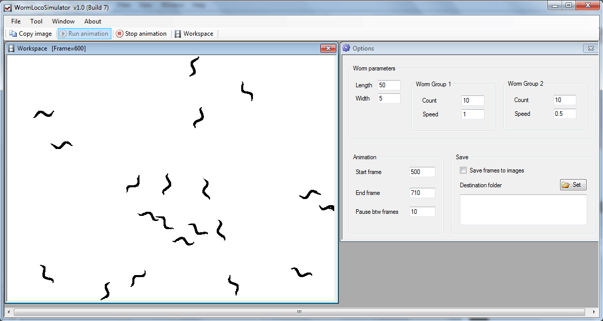

III. Source code & system requirements
- The software is written in VB.NET.
- The software can run on only Windows (XP or 7) computers.
- A user may have to install .Net (dot Net) framework (4.0 or higher)

IV. How to use
Step 1: Set parameters on the 'Options' window. Click on the 'Save frames to images' and the 'Set' button to set the destination folder on the 'Options' windows.
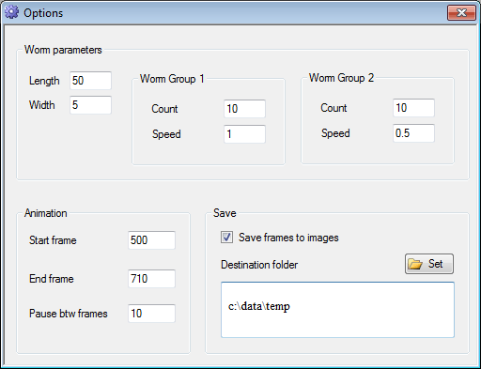
Length: worm length
Width: worm thickness
Count: the number of worms
Speed: velocity (pixels/frame)
Start frame: use default value (the first 499 frames will not be shown)
End frame: the last frame number

Step 2: Click on the 'Run animation' button. Animation will be initiated.
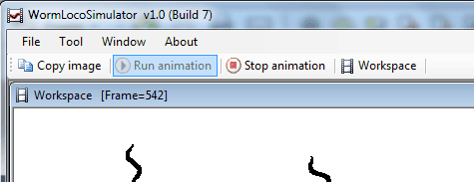
Many image frames will be created.
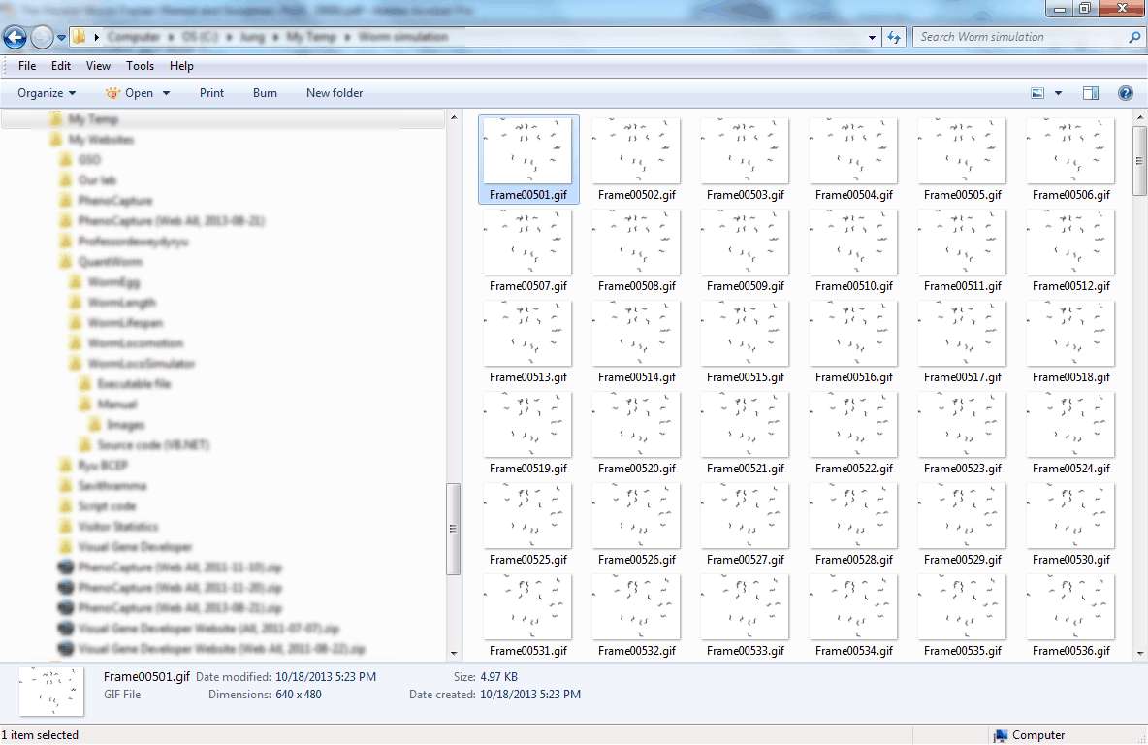

Step 3: Convert the image frames into video file.
Note: Because WormLocoSimulator does not have this function, a user has to use other software such as PhenoCapture (freely available at www.phenocapture.net).
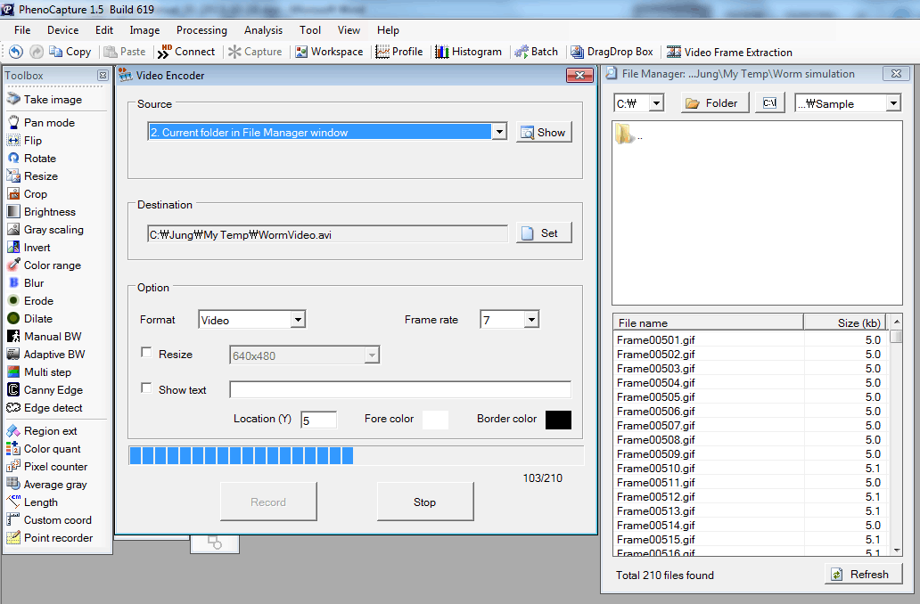
Click on the 'Create video or Animated Gif file from images' in the 'Tool' menu.
Set source image folders in the 'File Manager' window.
Choose 'Video' in the Format and set frame rate at 7 (frames/sec) in the 'Video Encoder' window.
Click on the 'Record' button in the 'Video Encoder' window.
For more details, check tutorials at PhenoCapture website.

Step 4: Create a log file (text file) of the video. The log file is needed for WormLocomotion software.
If video file name is 'Video1.avi', its log file name is 'Video1.txt'.
The log file contains the following keys and values whose unit is the 'micrometer/pixel'.

#StepsPerPixelsX 20
#StepsPerPixelsY 20

Check sample video and log file (Movie S1.avi and Movie S1.txt)

